Grade 4 Math Learning Activities
June 8 - 12

1.) Solving Equations
a.) y + 4 = 9 b.) m – 7 = 10 c.) 2 x a = 6 d.) h ÷ 2 = 7

e.) Tracy has 16 petunia plants and a tray of daisies. She has 37 plants altogether.
- Write an equation you could solve to find out how many daisy plants Tracy has.
- Solve the equation. How many daisy plants does Tracy have?
2.) Exploring Area
Example:
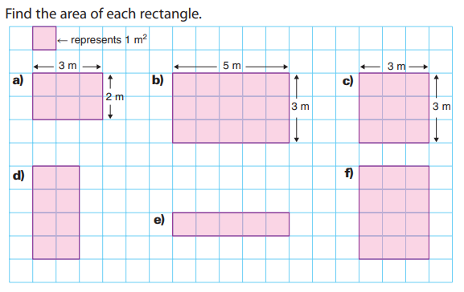

3.) Telling Time – 24-Hour Clock
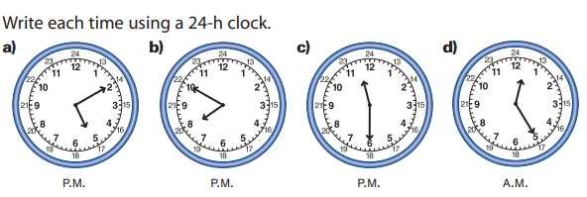

4.) Relating Multiplication to Division
**Use a multiplication fact to help you**
- Divide.

5.) Multiplication Bump
- Directions are at the bottom of the game sheet
- If you do not have dice, use your cards (only numbers 1 – 6, remove others)
- For the game pieces, use anything you have at home. You can even cut up two different colors of paper to use (10 of each colour).
