Grade 5 Math Learning Activities
June 8 - 12

1.) Fractions
Write a fraction for the shaded portion.
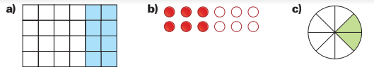

2.) Add or Subtract
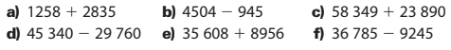
3.) Multiplication
4.) Division
5.) Patterns
- Copy the table.
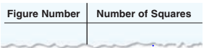

- Complete the table using the pattern below.
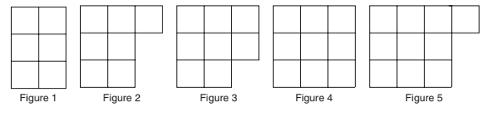
- Write the next 4 terms in the pattern.

6.) Multiplication Bump
- Directions are at the bottom of the game sheet
- If you do not have dice, use your cards (only numbers 1 – 6, remove others)
- For the game pieces, use anything you have at home. You can even cut up two different colors of paper to use (10 of each color).
