Grade 5 Math Learning Activities
April 20 - 24
For these activities, students will use a deck of cards with 10s and Face Cards removed (ace is 1). If you do not have cards, use small pieces of paper and make four sets of numbers of 1-10.
1.) Place Value
- Separate your cards into sets of hearts, clubs, spades, diamonds.
- Create 4 different 6-digit numbers using the digits 1,2,3,4,5,6.
- Order the numbers from greatest to least.
- Repeat several times with new numbers.

2.) Addition
- Create one 6-digit number and one 5-digit number.
- Add the numbers. (Remember to make sure your place value is lined up).
- Show your work and box in your answer.
- Repeat 5 times.

3.) Subtraction
- Create one 6-digit number and one 5-digit number.
- Subtract the numbers. (Remember to make sure your place value is lined up and that the largest number is first).
- Show your work and box in your answer.
- Repeat 5 times.

4.) Multiplication
- Create one 3-digit number and one 2-digit number.
- Multiply.
- Show your work and box in your answer. (Box Method)
- Repeat 5 times.
5.) Multiplication Game
Flip and Multiply (Play with a Partner or on your own and check your answers)
- Split the deck of cards into two equal groups.
- Each partner flips a card and take turns answering the math fact.
- Repeat several times.
**Feel free to adjust the game, by adding or subtracting the two numbers**

Example:
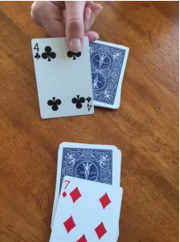
4 x 7 = 28

6.) Math Fact Practice
- The website math-drills.com has many practice pages to choose from that can be printed off or copied onto a piece of paper with the answers included to check your work. This week, the link will take you to division facts.
https://www.math-drills.com/division/division_facts_0109_0109_0_001.php

